

**SCHOOL OF COMPUTER SCIENCE ENGINEERING**

**Parking Management System**

**Vibhu Kumar Singh**

**19BCE0215**

**Mihir Gupta**

**19BCE0619**

**Avnish Tiwari**

**19BCE0634**

**Tushar Goel**

**19BCE2185**

**Project Report**

**of**

**CSE2006 – MICROPROCESSOR & INTERFACING**

**Fall Semester 2021-22**



**SCHOOL OF COMPUTER SCIENCE ENGINEERING**

**Parking Management System**

**Vibhu Kumar Singh Mihir Gupta**

**(19BCE0215) (19BCE0619)**

**Avnish Tiwari Tushar Goel**

**(19BCE0634) (19BCE2185)**

**Project Report**

**of**

**CSE2006 – Microprocessor & Interfacing**

**Fall Semester 2021-22**

**Submitted to**

**Faculty: Dr. E. Konguvel Signature:**

**Date: 8th December 2021**

**Slot: E2**

|  |  |
| --- | --- |
| **CONTENT** | **PAGE No.** |
| Abstract | 1 |
| Introduction | 2 |
| Literature Survey | 3 |
| Drawback of the existing work and the Proposed work | 5 |
| Block Diagram, pin diagram, flow chart | 6 |
| Implementation | 8 |
| Screenshots of the prototype | 10 |
| Results and Graphs | 11 |
| Conclusion | 12 |
| References | 13 |
| Appendix (code) | 14 |
| Plagiarism report | 20 |

**ABSTRACT**

Finding a perfect parking spot in today’s fast paced metropolitan cities, particularly during the busy times, is a huge headache for drivers. The trouble emerges from not knowing where the accessible spaces might be; regardless of whether known, numerous vehicles might seek after exceptionally restricted parking spots to cause genuine traffic gridlock. In this project, we design and emulate a model of Parking System that permits drivers to viably find empty parking spots utilizing assembly language. We have decided to emulate our project with the help of EMU 8086 emulator. With the help of our project, a parking facility manager can keep track of the number of two wheelers and 4 wheelers parked at a particular time, how many vacant spots are there for a particular type of vehicle (two and four wheelers), how many total vacant spots are left in the facility and also manage his earnings and profits.

1. **INTRODUCTION**

Finding a perfect parking spot in today’s fast paced metropolitan cities, particularly during the busy times, is a huge headache for drivers. The trouble emerges from not knowing where the accessible spaces might be; regardless of whether known, numerous vehicles might seek after exceptionally restricted parking spots to cause genuine traffic gridlock. In this project, we design and emulate a model of Parking System that permits drivers to viably find empty parking spots utilizing assembly language. We have decided to emulate our project with the help of EMU 8086 emulator. With the help of our project, a parking facility manager can keep track of the number of two wheelers and 4 wheelers parked at a particular time, how many vacant spots are there for a particular type of vehicle (two and four wheelers), how many total vacant spots are left in the facility and also manage his earnings and profits. This will help automate the parking lot and also make it easier to track sales of parking spaces and prevent traffic from accumulating inside the parking lot.

1. **LITERATURE REVIEW**

**1. Javaid, Sabeen & Sufian, Ali & Pervaiz, Saima & Tanveer, Mehak. (2018). Smart traffic management system using Internet of Things. 393-398. 10.23919/ICACT.2018.8323770.**

2018 20th International Conference on Advanced Communication Technology (ICACT)

Smart traffic management system using Internet of Things.

Traffic management system is considered as one of the major dimensions of a smart city. With the rapid growth of population and urban mobility in metropolitan cities, traffic congestion is often seen on roads. To tackle various issues for managing traffic on roads and to help authorities in proper planning, a smart traffic management system using the Internet of Things (IoT) is proposed in this paper. A hybrid approach (combination of centralized and decentralized) is used to optimize traffic flow on roads and an algorithm is devised to manage various traffic situations efficiently. For this purpose, the system takes traffic density as input from a) cameras b) and sensors, then manages traffic signals. Another algorithm based on Artificial Intelligence is used to predict the traffic density for future to minimize the traffic congestion. Besides this, RFIDs are also used to prioritize the emergency vehicles such as ambulances and fire brigade vehicles during a traffic jam. In case of fire on the road, Smoke sensors are also part of this system to detect this situation. To demonstrate the effectiveness of the proposed traffic management system, a prototype is developed which not only optimizes the flow of traffic but also connects nearby rescue departments with a centralized server. Moreover, it also extracts useful information presented in graphical formats that may help the authorities in future road planning.

**2. Pala, Z., & Inanc, N. (2007). Smart Parking Applications Using RFID Technology. 2007 1st Annual RFID Eurasia. https://doi.org/10.1109/RFIDEURASIA.2007.4368108**

2007 1st Annual RFID Eurasia

Smart Parking Applications Using RFID Technology

Check-ins and check-outs will be handled in a fast manner without having to stop the cars so that traffic jam problem will be avoided during these processes. Drivers will not have to stop at the circulation points and parking tickets will be out of usage during check-ins and check-outs. It will be avoided ticket- jamming problems for the ticket processing machines as well. Vehicle owners will not have to make any payments at each check-out thus a faster traffic flow will be possible. Since there won't be any waiting during check-ins and check-outs the formation of emission gas as a result of such waiting will be avoided. An atomized income tracking system, a car tracking system for charging and a central parking-car tracking system have been developed and utilized. Instead of cars' parking on streets, a more modern and a fast-operating parking-lot system have been developed.

**3. M. Sukru Kuran, Aline Carneiro Viana, Luigi Iannone, Daniel Kofman, Gregory Mermoud, et al.. A Smart Parking Lot Management System for Scheduling the Recharging of Electric Vehicles. IEEE Transactions on Smart Grid, Institute of Electrical and Electronics Engineers, 2015, 6 (6), pp.2942-2953**.

2015 IEEE Transactions on Smart Grid

A Smart Parking Lot Management System for Scheduling the Recharging of Electric Vehicles

In this paper, they propose a centralized electric vehicles (EVs) recharge scheduling system for parking lots using a realistic vehicular mobility/parking pattern focusing on individual parking lots. We consider two different types of EV based on their mobility/parking patterns: 1) regular EVs; and 2) irregular EVs. An extensive trace-based vehicular mobility model collected from the Canton of Zurich is used for the regular EVs, and a probabilistic pattern built on top of this trace is used for modelling the behavior of irregular EVs. To the extent of our knowledge, this is the first EV charging scheduling study in the literature that takes into account a realistic vehicular mobility pattern focusing on individual parking lots. We compare the performance of our proposed system with two well-known basic scheduling mechanisms, first come first serve and earliest deadline first, with regard to two objective functions: 1) maximizing the total parking lot revenue; and 2) maximizing the total number of EVs fulfilling their requirements. Comparison results show that our proposed system outperforms well-known basic scheduling mechanisms with regards to both objectives. Parking lots managing the recharging of a high number of EVs will greatly benefit from using such recharge scheduling systems in the context of smart cities.

**4. Ghazal, Bilal & Khatib, Khaled & Chahine, Khaled & Kherfan, Mohamad. (2016). Smart traffic light control system. 140-145. 10.1109/EECEA.2016.7470780.**

2016 Third International Conference on Electrical, Electronics, Computer Engineering and their Applications (EECEA)

Smart traffic light control system

Traffic light control systems are widely used to monitor and control the flow of automobiles through the junction of many roads. They aim to realize smooth motion of cars in the transportation routes. However, the synchronization of multiple traffic light systems at adjacent intersections is a complicated problem given the various parameters involved. Conventional systems do not handle variable flows approaching the junctions. In addition, the mutual interference between adjacent traffic light systems, the disparity of cars flow with time, the accidents, the passage of emergency vehicles, and the pedestrian crossing are not implemented in the existing traffic system. This leads to traffic jam and congestion. We propose a system based on PIC microcontroller that evaluates the traffic density using IR sensors and accomplishes dynamic timing slots with different levels. Moreover, a portable controller device is designed to solve the problem of emergency vehicles stuck in the overcrowded roads.

**5. A. K. Sikder, A. Acar, H. Aksu, A. S. Uluagac, K. Akkaya and M. Conti, "IoT-enabled smart lighting systems for smart cities," 2018 IEEE 8th Annual Computing and Communication Workshop and Conference (CCWC), 2018, pp. 639-645, doi: 10.1109/CCWC.2018.8301744.**

2018 IEEE 8th Annual Computing and Communication Workshop and Conference (CCWC)

IoT-enabled smart lighting systems for smart cities

Over the past few decades, the rate of urbanization has increased enormously. More enhanced services and applications are needed in urban areas to provide a better lifestyle. Smart city, which is a concept of interconnecting modern digital technologies in the context of a city, is a potential solution to enhance the quality and performance of urban services. With the introduction of Internet-of-Things (IoT) in the smart city, new opportunities have emerged to develop new services and integrate different application domains with each other using Information and Communication Technologies. However, to ensure seamless services in an IoT-enabled smart city environment, all the applications have to be maintained with limited energy resources. One of the core sectors that can be improved significantly by implementing IoT is the lighting system of a city since it consumes more energy than other parts of a city. In a smart city, the lighting system is integrated with advanced sensors and communication channels to obtain a Smart Lighting System (SLS). The goal of an SLS is to obtain an autonomous and more efficient lighting management system. In this paper, we provide an overview of the SLS and review different IoT-enabled communication protocols, which can be used to realize the SLS in the context of a smart city. Moreover, we analyzed different usage scenarios for IoT- enabled indoor and outdoor SLS and provide an analysis of the power consumption. Our results reveal that IoT-enabled smart lighting systems can reduce power consumption up to 33.33% in both indoor and outdoor settings. Finally, we discussed the future research directions in SLS in the smart city.

**6. Lanke, Ninad & Koul, Sheetal. (2013). Smart Traffic Management System. International Journal of Computer Applications. 75. 19-22. 10.5120/13123-0473.**

International Journal of Computer Applications (0975 – 8887) 2013.

Smart Traffic Management System

Traffic congestion is a major problem in many cities of India along with other countries. Failure of signals, poor law enforcement and bad traffic management has lead to traffic congestion. One of the major problems with Indian cities is that the existing infrastructure cannot be expanded more, and thus the only option available is better management of the traffic. Traffic congestion has a negative impact on economy, the environment and the overall quality of life. Hence it is high time to effectively manage the traffic congestion problem. There are various methods available for traffic management such as video data analysis, infrared sensors, inductive loop detection, wireless sensor network, etc. All these methods are effective methods of smart traffic management. But the problem with these systems is that the installation time, the cost incurred for the installation and maintenance of the system is very high. Hence a new technology called Radio Frequency Identification (RFID) is introduced which can be coupled with the existing signalling system that can act as a key to smart traffic management in real time. This new technology which will require less time for installation with lesser costs as compared to other methods of traffic congestion management. Use of this new technology will lead to reduced traffic congestion. Bottlenecks will be detected early and hence early preventive measures can be taken thus saving time and money off the driver.

**7. Chew, Ivan & Karunatilaka, Dilukshan & Tan, Chee Pin (Edwin) & Kalavally, V.. (2017). Smart lighting: The way forward? Reviewing the past to shape the future. Energy and Buildings. 149. 10.1016/j.enbuild.2017.04.083**

May 2017

Smart lighting: The way forward? Reviewing the past to shape the future. Energy and Buildings.

The push for ubiquitous networking and device inter-connectivity in buildings is fuelling the development of a new wave of smart devices with embedded electronics, sensors and wireless connectivity that can collect, process and exchange data. Commonly known as the Internet of Things (IoT), it encompasses, but is not limited to wireless sensor networks, home automation, mobile devices and lighting control systems. Smart lighting systems are of particular interest as they evolve from traditional lighting control by introducing autonomous control of light through feedback from integrated sensors, user data, cloud services and user input, bringing with it a host of benefits including increased energy savings, enhanced functionality, and user-centric lighting. In this paper, we review the current state of the art in smart lighting technology, focusing on energy-saving, commercial, and advanced smart lighting systems. Furthermore, we also present a review of smart lighting connectivity options and discuss potential advancements through the integration of visible light communication technology.

1. **DRAWBACK IN THE EXISTING WORK**

After carefully reviewing the research papers and journals related to our topic, we figured that most of the projects have used IOT based smart systems to simulate their models, which requires physical microprocessors such as Arduino/Raspberry Pi etc. We were not able to find a lot material on how to simulate the Parking management System with the need of a microprocessor using just Machine Level code.

1. **PROPOSED WORK**

Since, there is little implementation of a full-fledged Management System in Assembly Language, we decided to simulate our idea, using nothing but Machine Level code. Since, the Assembly Language is the lowest level language that a machine can understand, it is clear that the System will be quicker than most or all of the systems built in any other language (example: Python/C++/Java/Javascript…).

1. **BLOCK DIAGRAM AND FLOW CHART FOR THE ALGORITHM**

5.1 BLOCK DIAGRAM:

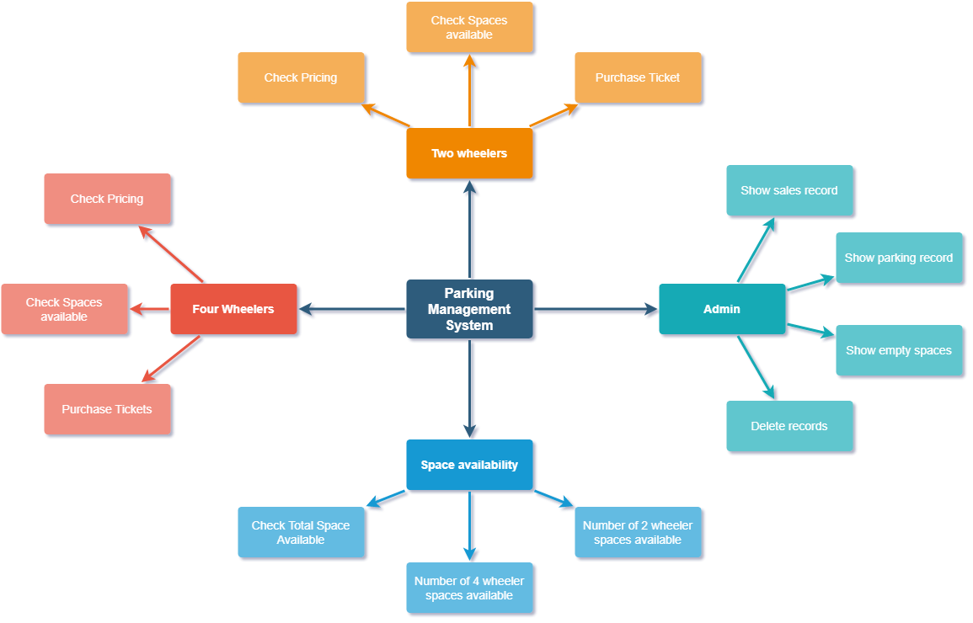

* 1. FLOWCHARTS:

5.2.1 Main Menu Flowchart:

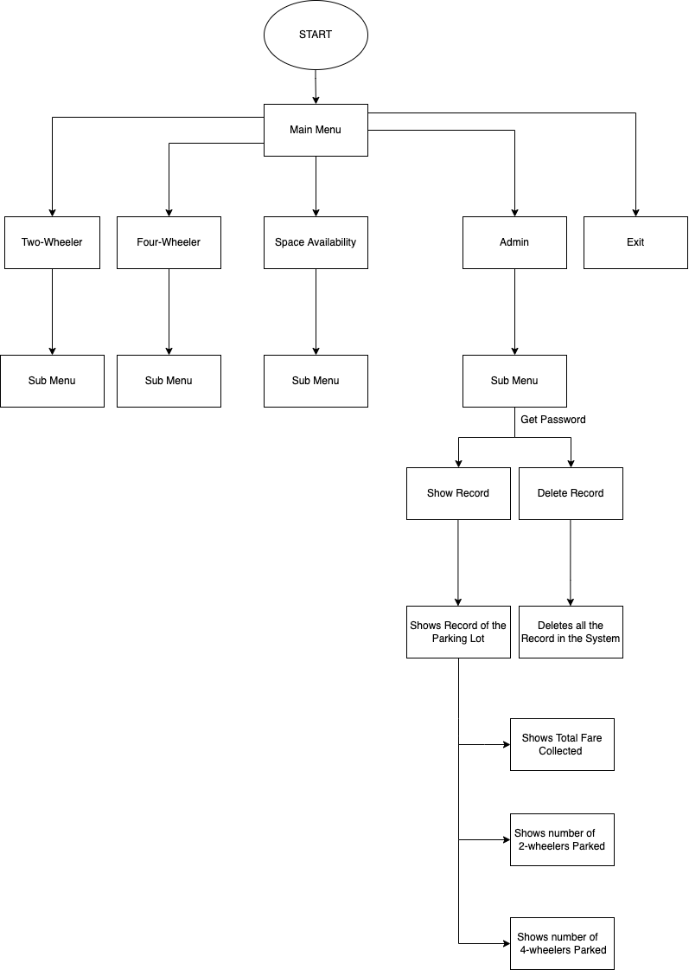

5.2.2 Two-Wheeler Flowchart:

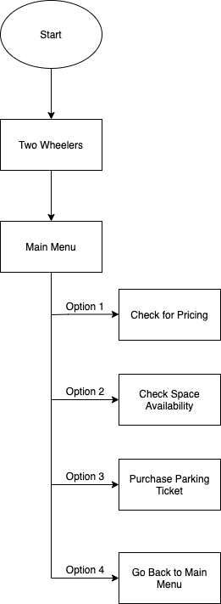

5.2.3 Four-Wheeler Flowchart:

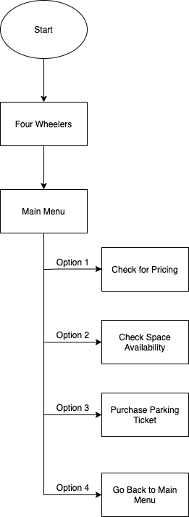

5.2.4 Check Space Availability Flowchart:

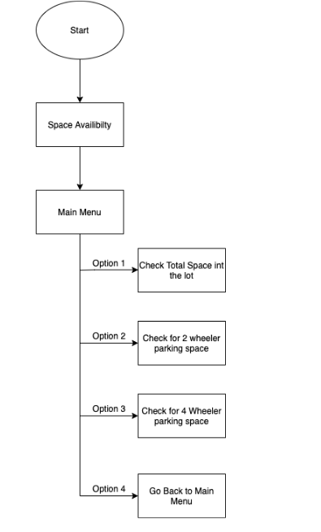

5.2.5 Admin Flowchart:

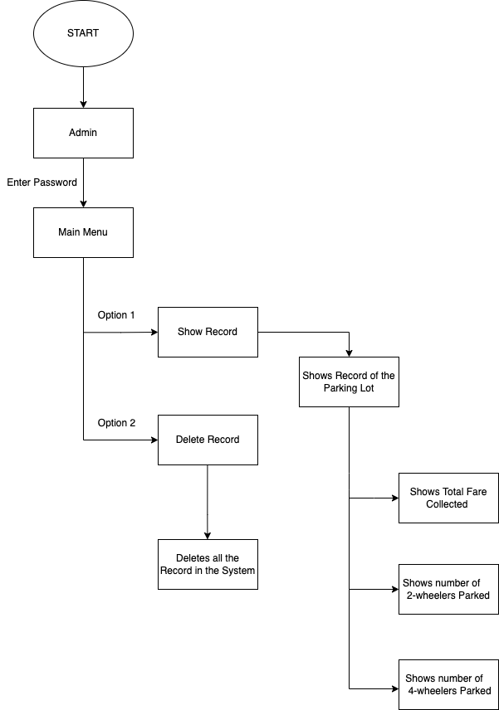

1. **IMPLEMENTATION**

When we first run the program, the user is greeted with a welcome message along with the project details such as the creators’ names and their respective registration number. The user is prompted to press any key to enter the “PARKING MANAGEMENT SYSTEM”.

The main menu comprises of 4 options, ie:

* Two Wheeler
* Four Wheeler
* Check Space Availability
* Admin

The last option (EXIT) allows the user to terminate out of the system. The Main Menu is broken down into the following modules:

6.1 TWO-WHEELER

When the user chooses “TWO-WHEELER” option, the user is taken to the Two-Wheeler menu and he/she can now from the following options:

* Pricing: This will show the user the price of a two-wheeler parking ticket.
* Check Space Availability: This will show the user the number of parking slots left for a two-wheeler.
* Purchase Parking Ticket: On choosing this option, the user is prompted to confirm if he/she wants to buy the ticket, if yes, the user is charged Rs. 200 and the console returns to the Main Menu.
* Go Back: The user can go back to the Main Menu by using this option.
  1. FOUR-WHEELER

When the user chooses “FOUR-WHEELER” option, the user is taken to the Four-Wheeler menu and he/she can now from the following options:

* Pricing: This will show the user the price of a four-wheeler parking ticket.
* Check Space Availability: This will show the user the number of parking slots left for a four-wheeler
* Purchase Parking Ticket: On choosing this option, the user is prompted to confirm if he/she wants to buy the ticket, if yes, the user is charged Rs. 400 and the console returns to the Main Menu.
* Go Back: The user can go back to the Main Menu by using this option.
  1. CHECK SPACE AVAILABILITY

This option allows the user to glance at the current status of the Parking Lot. It shows the total number of slots left for both Two-wheelers and Four-wheels (combined and individually). The user can check the availability of a space for his/her vehicle with just a press of a button, hence saving time.

* 1. ADMIN

The system contains some data which can only be accessed by an Administrator of the Parking Management System. In order to prevent just anyone to enter the Admin Module and access sensitive data, this module has been password protected. When the right password is entered, the administrator can access the Details such as the total amount collected through parking ticket sales.

If the need be, the admin also has the option to delete the whole database. This will clear all data in the parking system.

Finally, the user can press 5 in the Main Menu to exit the program.

1. **SCREENSHOTS OF PROTOTYPE**

7.1 Welcome Screen:

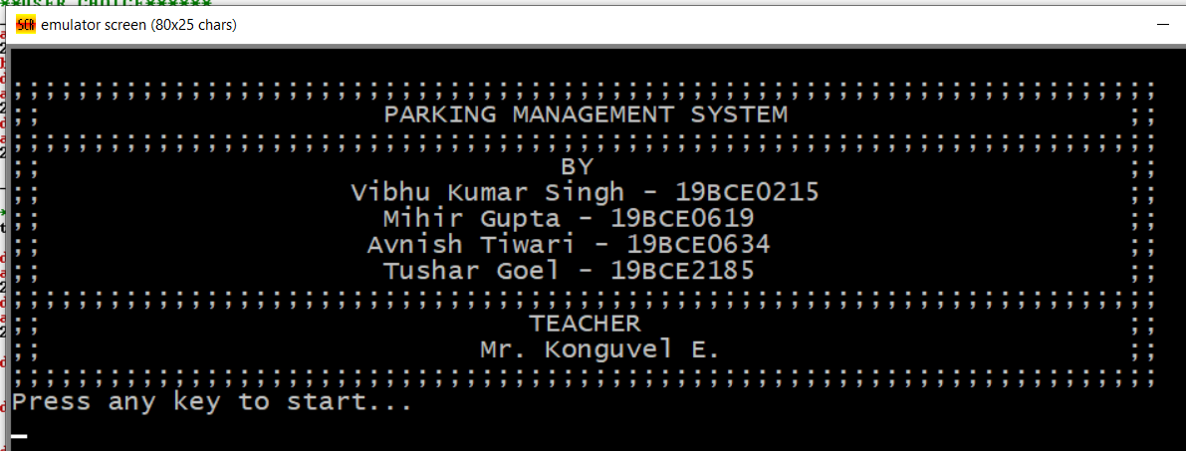

7.2 Main Menu:

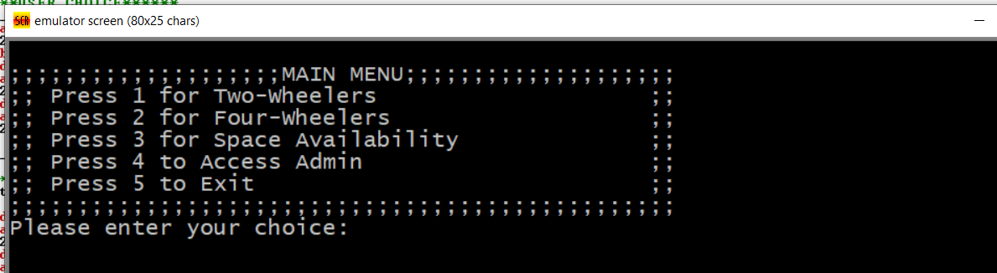

7.2.1 Two-Wheeler:

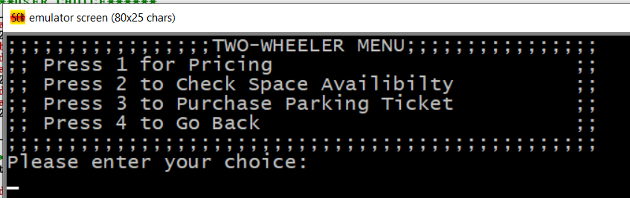

Pricing:

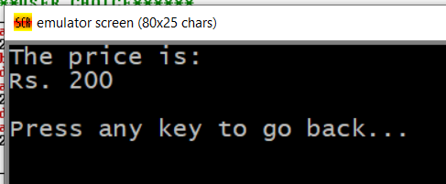

Check Availability:

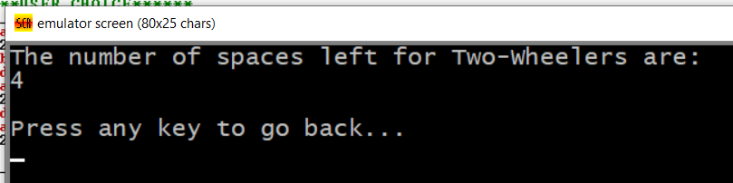

Purchase Ticket:

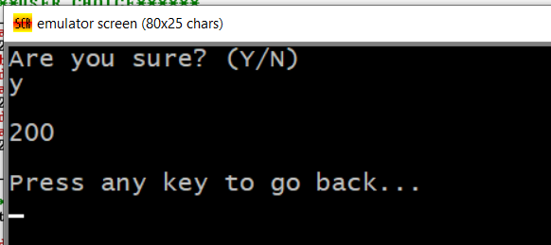

7.2.2 Four-Wheeler:

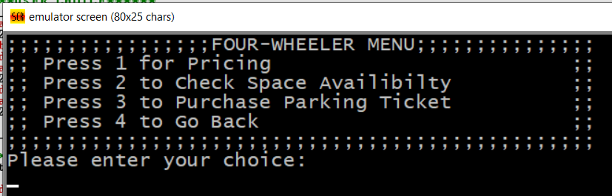

Pricing:

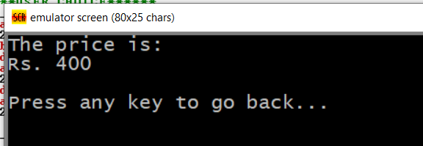

Check Availability:

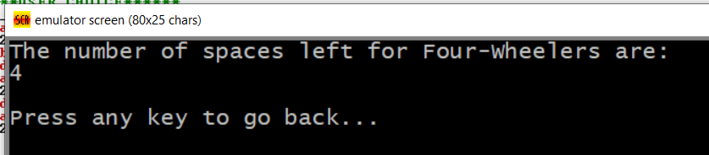

Purchase Ticket:

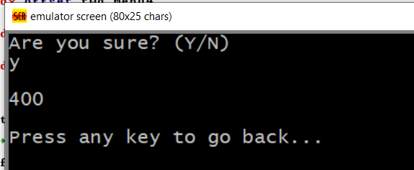

7.2.3 Check Space Availability:

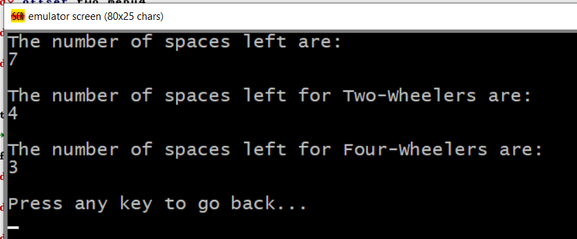

7.2.4 Admin:

Password Screen:

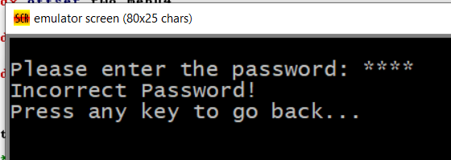

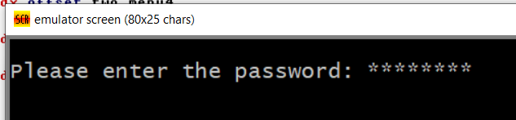

Admin Dashboard:

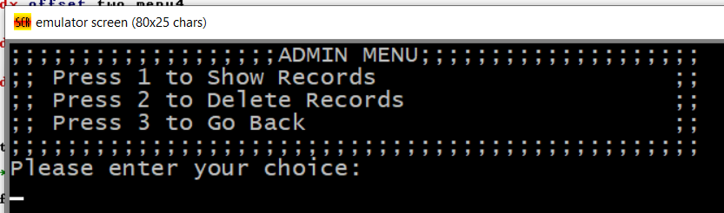

Show Records:

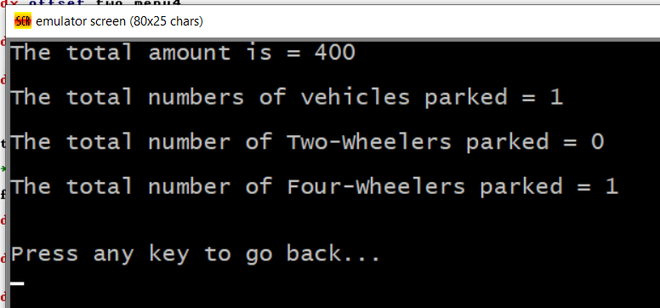

Delete Records:

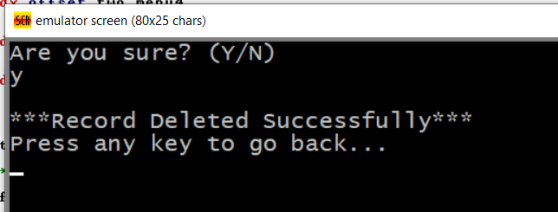

1. **RESULTS**

The built system is robust and has no loopholes in terms of safety. This system can further be optimized by adding the following functionality:

* All the data can be stored in a database, in order to make data persistent.
* There can be a way to keep track of the exact slots (Slot No.) that are empty.
* This system can be extended to a multilevel parking, where the user is indicated on which exact floor he/she needs to park their vehicle.

What we have built is an implementation of a basic idea about making the parking experience better for the customers and the workers.

1. **CONCULSION**

As the research demonstrated, the idea was to build a system to increase the efficiency of parking lots as much as possible. We can see that this was achieved using Assembly Language code, 8086 Assembly Language to be more specific. A user can easily check for available slots, purchase a parking ticket and park their vehicle without wasting time. As a plus, the admin module adds more safety and functionality to the system. It is clear that the Parking Management System is fast, user friendly and efficient.

1. **REFERENCES**
2. **APPENDIX (CODE)**
3. **PLAGIARISM REPORT**

**Date: December, 08 2021**

PLAGIARISM SCAN REPORT



**0%**

**Plagiarised**



**100%**

**Unique**



**936**

**Words**



**5770**

**Characters**

**Excluded Url** : None

Content Checked For Plagiarism

ABSTRACT Finding a perfect parking spot in today’s fast paced metropolitan cities, particularly during the busy times, is a huge headache for drivers. The trouble emerges from not knowing where the accessible spaces might be; regardless of whether known, numerous vehicles might seek after exceptionally restricted parking spots to cause genuine traffic gridlock. In this project, we design and emulate a model of Parking System that permits drivers to viably find empty parking spots utilizing assembly language. We have decided to emulate our project with the help of EMU 8086 emulator. With the help of our project, a parking facility manager can keep track of the number of two wheelers and 4 wheelers parked at a particular time, how many vacant spots are there for a particular type of vehicle (two and four wheelers), how many total vacant spots are left in the facility and also manage his earnings and profits. 1. INTRODUCTION Finding a perfect parking spot in today’s fast paced metropolitan cities, particularly during the busy times, is a huge headache for drivers. The trouble emerges from not knowing where the accessible spaces might be; regardless of whether known, numerous vehicles might seek after exceptionally restricted parking spots to cause genuine traffic gridlock. In this project, we design and emulate a model of Parking System that permits drivers to viably find empty parking spots utilizing assembly language. We have decided to emulate our project with the help of EMU 8086 emulator. With the help of our project, a parking facility manager can keep track of the number of two wheelers and 4 wheelers parked at a particular time, how many vacant spots are there for a particular type of vehicle (two and four wheelers), how many total vacant spots are left in the facility and also manage his earnings and profits. This will help automate the parking lot and also make it easier to track sales of parking spaces and prevent traffic from accumulating inside the parking lot. 6. IMPLEMENTATION When we first run the program, the user is greeted with a welcome message along with the project details such as the creators’ names and their respective registration number. The user is prompted to press any key to enter the “PARKING MANAGEMENT SYSTEM”. The main menu comprises of 4 options, ie: - Two Wheeler - Four Wheeler - Check Space Availability - Admin The last option (EXIT) allows the user to terminate out of the system. The Main Menu is broken down into the following modules: 6.1 TWO-WHEELER When the user chooses “TWO-WHEELER” option, the user is taken to the Two-Wheeler menu and he/she can now from the following options: - Pricing: This will show the user the price of a two-wheeler parking ticket. - Check Space Availability: This will show the user the number of parking slots left for a two-wheeler. - Purchase Parking Ticket: On choosing this option, the user is prompted to confirm if he/she wants to buy the ticket, if yes, the user is charged Rs. 200 and the console returns to the Main Menu. - Go Back: The user can go back to the Main Menu by using this option. 6.2 FOUR-WHEELER When the user chooses “FOUR-WHEELER” option, the user is taken to the Four-Wheeler menu and he/she can now from the following options: - Pricing: This will show the user the price of a four-wheeler parking ticket. - Check Space Availability: This will show the user the number of parking slots left for a four-wheeler - Purchase Parking Ticket: On choosing this option, the user is prompted to confirm if he/she wants to buy the ticket, if yes, the user is charged Rs. 400 and the console returns to the Main Menu. - Go Back: The user can go back to the Main Menu by using this option. 6.3 CHECK SPACE AVAILABILITY This option allows the user to glance at the current status of the Parking Lot. It shows the total number of slots left for both Two-wheelers and Four-wheels (combined and individually). The user can check the availability of a space for his/her vehicle with just a press of a button, hence saving time. 6.4 ADMIN The system contains some data which can only be accessed by an Administrator of the Parking Management System. In order to prevent just anyone to enter the Admin Module and access sensitive data, this module has been password protected. When the right password is entered, the administrator can access the Details such as the total amount collected through parking ticket sales. If the need be, the admin also has the option to delete the whole database. This will clear all data in the parking system. Finally, the user can press 5 in the Main Menu to exit the program. 8. RESULTS The built system is robust and has no loopholes in terms of safety. This system can further be optimized by adding the following functionality: -

All the data can be stored in a database, in order to make data persistent. - There can be a way to keep track of the exact slots (Slot No.) that are empty. - This system can be extended to a multilevel parking, where the user is indicated on which exact floor he/she needs to park their vehicle. What we have built is an implementation of a basic idea about making the parking experience better for the customers and the workers. 9. CONCULSION As the research demonstrated, the idea was to build a system to increase the efficiency of parking lots as much as possible. We can see that this was achieved using Assembly Language code, 8086 Assembly Language to be more specific. A user can easily check for available slots, purchase a parking ticket and park their vehicle without wasting time. As a plus, the admin module adds more safety and functionality to the system. It is clear that the Parking Management System is fast, user friendly and efficient

